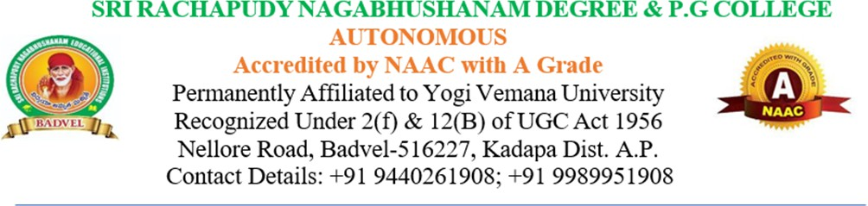
This is to certify that the following are the details available at Sri Rachapudy Nagabhushanam Degree and PG College (A), Badvel.
Total Built up area Details
Sl. No. | Particulars | Carpet Area Required as per AICTE Norms in Sq.mt | Carpet Area Available in Sq.mt
1 | Instructional Area | 1836 | 2155
2 | Administrative Area | 800 | 820
3 | Amenities Area | 468 | 488
 | Total Area | 3104 | 3464

Instructional Area:
Sl. No. | Particulars | No. of Rooms | Carpet Area in Sq.mt
1 | Classroom (BCA) | 6 | 396
2 | Classroom (MBA) | 4 | 264
3 | Classroom (MCA) | 4 | 264
4 | Computer Centre (MBA) | 1 | 150
5 | Computer Centre (MCA) | 1 | 150
6 | Computer Laboratory (MCA) | 1 | 66
7 | Language Laboratory (BCA) | 1 | 33
8 | Library & Reading Room | 1 | 150
9 | Seminar Hall (for MBA) | 1 | 132
10 | Seminar Hall (for MCA) | 1 | 132
11 | Tutorial Room (BCA) | 1 | 33
12 | Tutorial Room (MBA) | 1 | 33
13 | Tutorial Room (MCA) | 1 | 33
 | Total |  | 1836 Sq. Mt

Administrative Area
Sl. No. | Particulars | No. of Rooms | Carpet Area in Sq.mt
1 | Reception Area | 1 | 150
2 | Faculty Room | 1 | 20
3 | Department Office | 1 | 60
4 | Exam Control  Office | 1 | 30
5 | Office All Inclusive | 1 | 300
6 | Central Store | 1 | 30
7 | Placement Office | 1 | 30
8 | Principal/Directors  Office | 1 | 30
9 | Board Room | 1 | 20
10 | HoD-Dept of Business Administration’s Office | 1 | 60
11 | HoD-Dept of Computer Application’s Office | 1 | 60
12 | Security | 1 | 10
 | Total |  | 800 Sq. Mt

Amenities Area
Sl. No | Particulars | Carpet Area in Sq.mt
1 | Girls Common  Room | 100
2 | Boys Common  Room | 100
3 | Sports Club | 26
4 | Cafeteria | 150
5 | First aid cum Sick  Room | 10
6 | Toilet (Girls) | 26
7 | Toilet (Boys) | 26
8 | Maintenance | 10
9 | House Keeping | 10
10 | Stationery store | 10
 | Total | 468 Sq. Mt

Computer facilities (number, configuration, internet bandwidth)
Number of Computers | Configuration | Internet Bandwidth
100 | Intel Core i5, ROM-238 GB, RAM-8 GB, HD- 1TB | 300 MBPS
20

Seminar Halls
Seminar Halls I | MBA | Room No-
Seminar Halls II | MCA | Room No-
Seminar Halls III | BCA | Room No-

Sports Facilities:
Summary – Sports Facilities
S. No. | Name of the Sport | Item/Equipment | No. of Items available
 | Chess | Board | 7
 | Carroms | Carrom Board | 4
 | Badminton | Rockets | 24
 | Basket Ball | Ball | 5
 | Kabaddi | - | 2
 | Volley Ball | Volley Balls | 4
 | Throw Ball | Throw Balls | 4
 | Cricket | Cricket Mat | 2
 | Cricket | Cricket Bats | 5
 | Cricket | Cricket Balls | 10
 | Cricket | Cricket Stumps | 12
 | Cricket | Cricket Guard | 10
 | Cricket | Cricket Helmets | 6
 | Cricket | Cricket Pads | 12
 | Cricket | Cricket Gloves | 12

